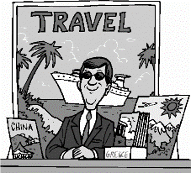
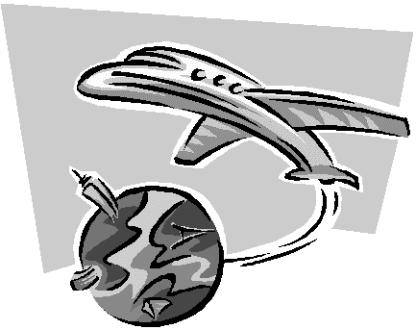
Everyone has dreamt about traveling around the world to interesting places. Pretend you own a travel agency and you need to inform customers of a new, interesting destination. In order to inform and persuade you customers to want to visit this place you must create a brochure about it. You will use Microsoft Word (not PowerPoint) to create the brochure. There are several templates you can use and many ways to customize your brochure by changing font color and size, adding pictures, etc. Here is how to get started:
Travel Brochure
Planning the brochure:
- Pick a country or city anywhere around the world to begin researching. Research and take notes on the following information. (your brochure needs to include the following information)
- Brief summary of the country or city
- Location, including a map and its geography
- Highlight of major cities, well-known places, historic sites and landmarks
- Recreation and Outdoor activities – parks, sports, water
- Entertainment, including museums, theaters, places to visit
- Arts and Culture
- Important Facts: Climate and overall weather conditions, Languages and local dialect, currency, flag, population, etc.
- Pictures / Graphics that relate to what you are talking about
- Any additional information that you find interesting to share
Each part above does not need its own section, but each piece of information should be included!
- Once you have all the information, think about and plan the overall brochure. Remember you are describing this travel destination to your readers. Start by deciding in what order you would like to place all of the information. Think of the most logical order all the information should be in.
Modifying the brochure:
- The brochure must fit on an 8 ½” x 11” paper. Be careful when you select a template because some of them are for 8 ½” x 14”
- You may use any type of brochure. Single page, trifold, etc.
- When you have completed your brochure you will use Outlook and email it to me at paraziner@santarosa.k12.fl.us I will then print your brochure.

Things to remember:
- The picture on the front should pull the reader into the publication.
- The font size of the title on each section (including the front panel) should be bold and large, but in balance with the photographs.
- Include a caption under the photographs being shown in the brochure. Real photos always work better than clip art.
- Have a plan ready of what you would like to place on each of the panels of the brochure. (Look at the bullet points on the first page of these instructions).
- Use pictures and detailed information.
Rubric for grading:
Category | 4 | 3 | 2 | 1
Attractiveness & Organization | The brochure has exceptionally attractive formatting and well-organized information. | The brochure has attractive formatting and well-organized information. | The brochure has well-organized information. | The brochure’s formatting and organization of material are confusing to the reader.
Graphics/Pictures | Graphics go well with the text and there is a good mix of text and graphics. | Graphics go well with the text, but there are so many that they distract from the text. | Graphics go well with the text, but there are too few and the brochure seems “text-heavy”. | Graphics do not go with the accompanying text or appear to be randomly chosen.
Writing/Grammar | There are no grammatical mistakes in the brochure. | There are no grammatical mistakes in the brochure after feedback from others. | There are 1-2 grammatical mistakes in the brochure, even after feedback. | There are several grammatical mistakes in the brochure, even after feedback.
Writing Mechanics | Capitalization and punctuation are correct throughout the brochure. | Capitalization and punctuation are correct after feedback from others. | There are 1-2 capitalization and/or punctuation errors in the brochure. | There are several capitalization errors in the brochure.
Spelling and proofreading. | No spelling errors remain after someone other than the typist reads and corrects the brochure. | No more than 1 spelling error after someone reads and corrects the brochure. | No more than 3 spelling errors remain after someone reads and corrects the brochure. | Several spelling errors in the brochure.

